**How to Train the Model in IBM cloud**

**Step 1**: Login/Signup to IBM cloud account (<https://cloud.ibm.com/>)

**Step 2**: Add the services needed to train the model

**Required Services**:

* + 1. Knowledge Studio-ih
    2. Natural language Understanding-a0

**Step 3**: Search the services in search tab and select the plan accordingly to add into your account.

**Step 4**: Launch Watson Knowledge Studio which is required to train the model.

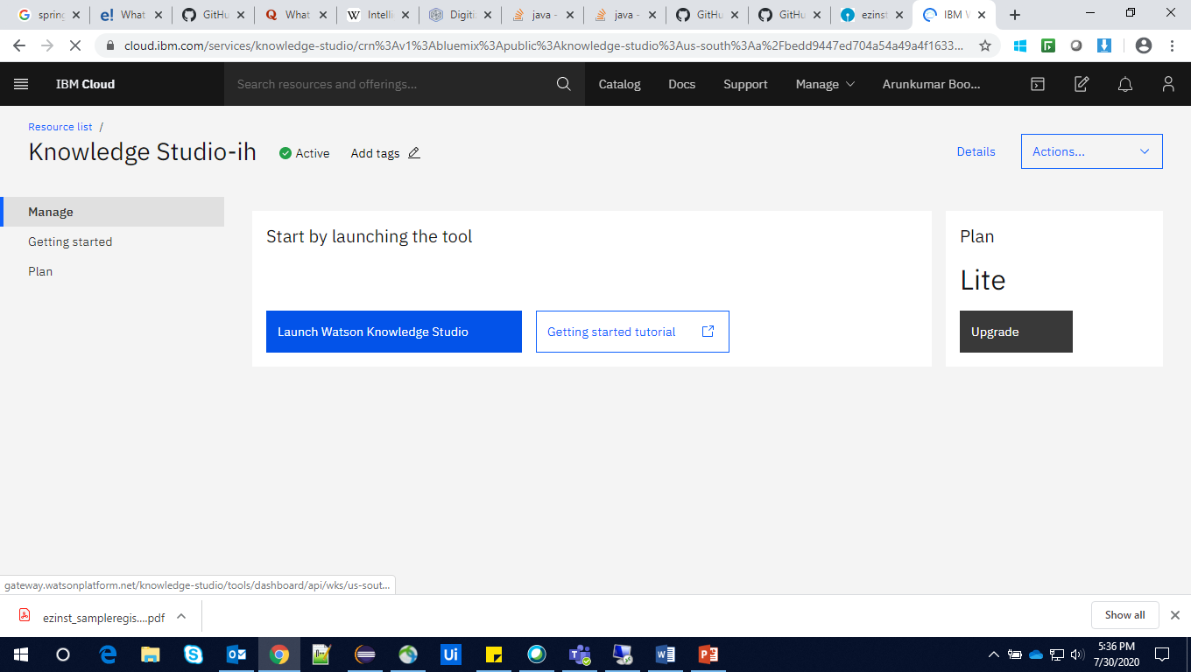

**Creating a workspace**

Need to create workspace to create a machine learning model, including training documents.

After launching the Watson knowledge studio it will be redirected to workspace creation page.

**Step 1**: Click on the create workspace icon.

**Step 2**: Give the workspace name and select the language and create it.

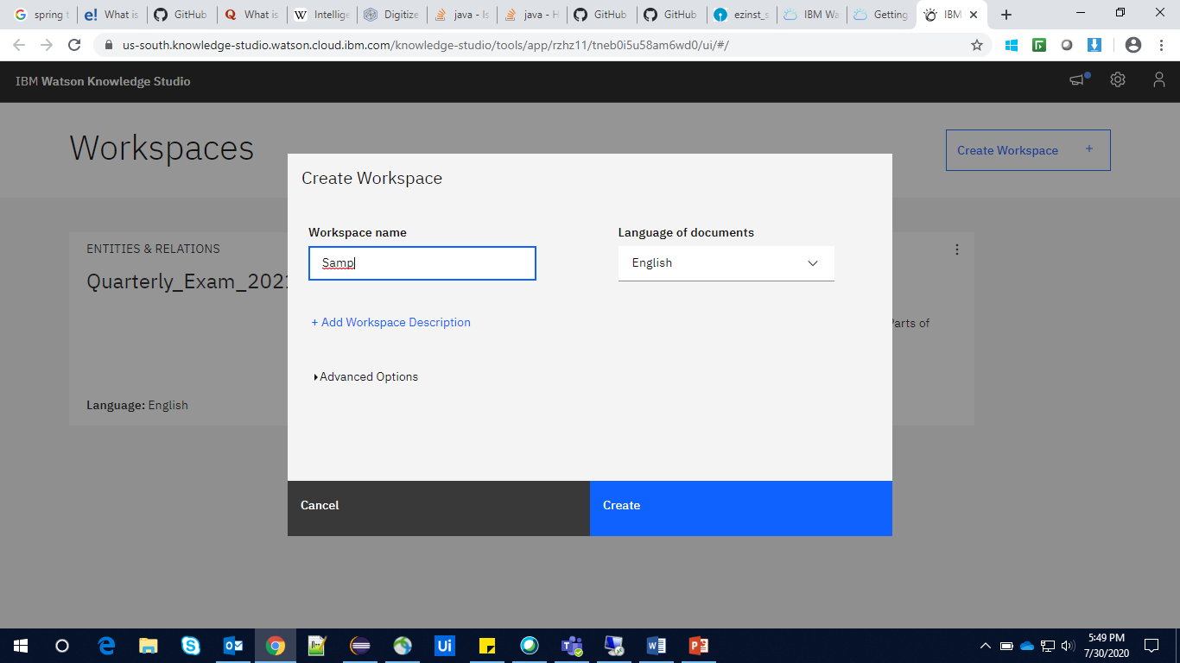

The workspace is created and opens automatically.

**Upload Documents**

Create the document which to tag the Entity type.

Supported file types: CSV, TXT, PDF, DOC, DOCX, HTML, ZIP

**Step 1**: Click **Assets> Documents**

**Step 2**: click upload document sets.

**Step 3**: Select the file and click upload**.**

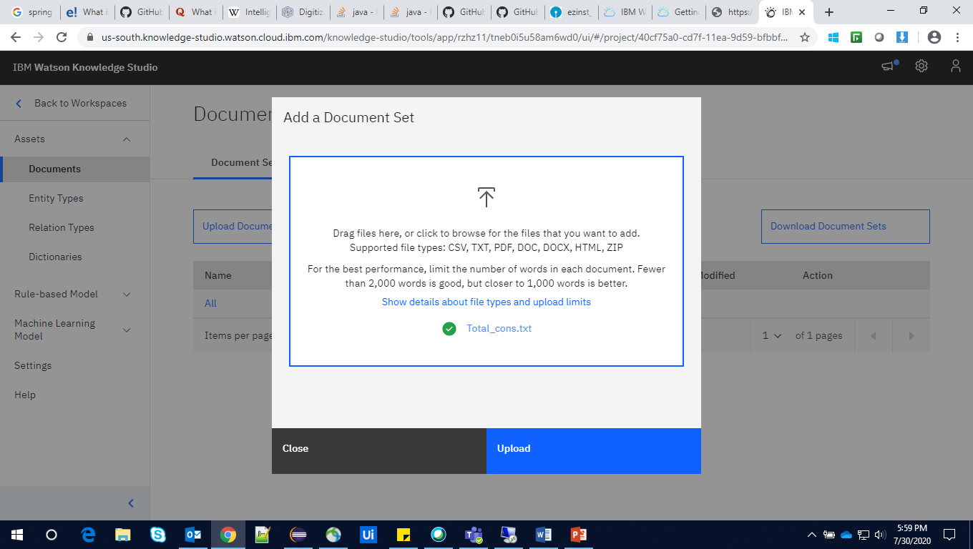

We can see the document details once it is uploaded.

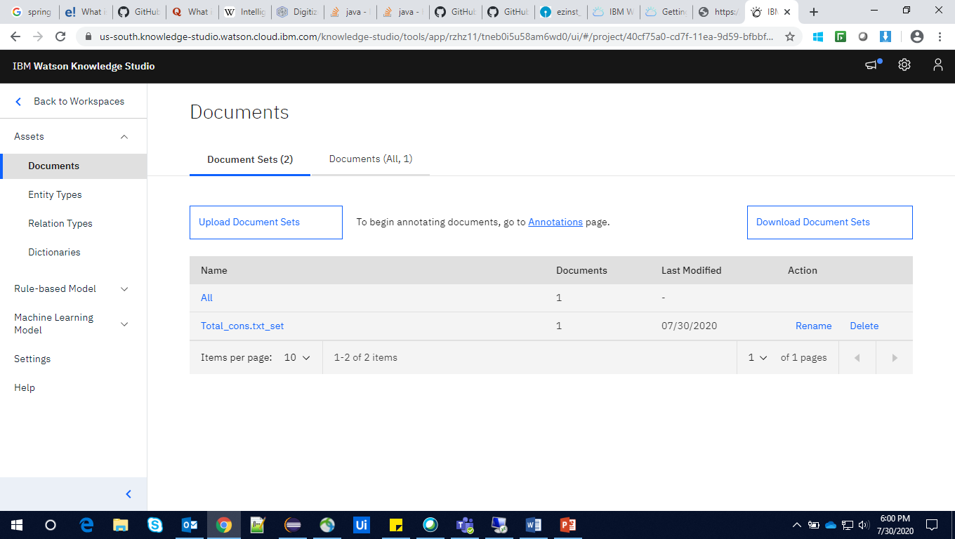

**Creating Entity Types:**

**Step 1**: Click **Assets**> **Entity Types**.

**Step 2**: Click Add **Entity type**.

**Step 3**: Give the entity name which should be unique (Here Question act as entity type).

**Step 4**: Click on **save**.

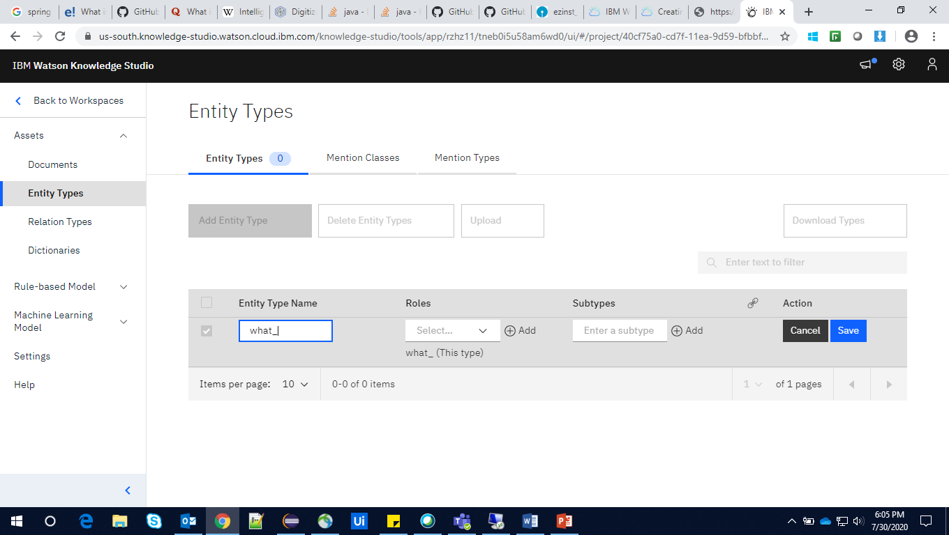

Add many entities as required.

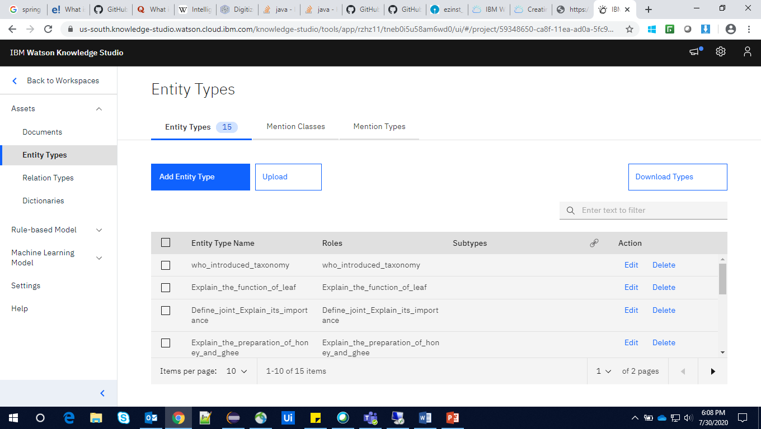

**Creating an annotation task**  
*annotation set* is a subset of documents from an uploaded document set that you assign.

Example: To map the key words (key answers) to the entity type (Questions) we have created earlier.

**Step 1**: click **Machine Learning Model** > **Annotations**

**Step 2:** Click the **Annotation Tasks** tab, then click **Add Task**

**Step 3:** Click **Create Annotation Sets.**

**Step 4:** Select the document set as base set and annotator and give the set name then click generate

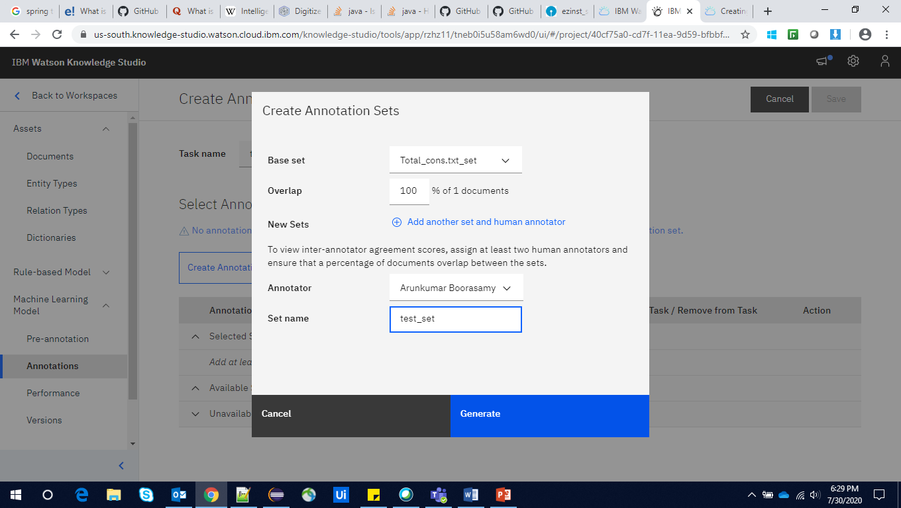

**Step 5**: Specify the details for the task:

In the **Task name** field, enter the name

In the **Deadline** field, select a date in the future

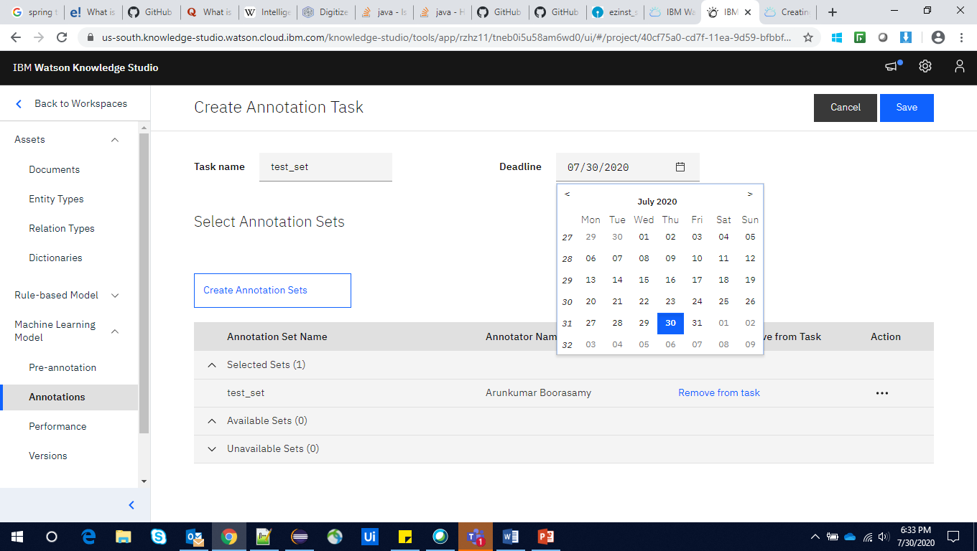

**Step 6**: Click **save**

**Step 7**: Once the task created, click on the task.

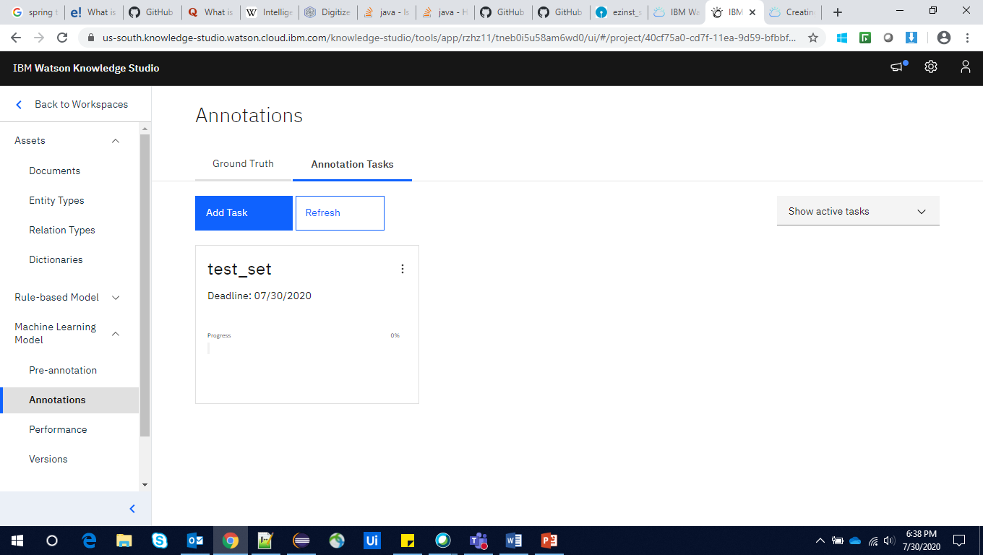

**Step** **8**: Click on **annotate**

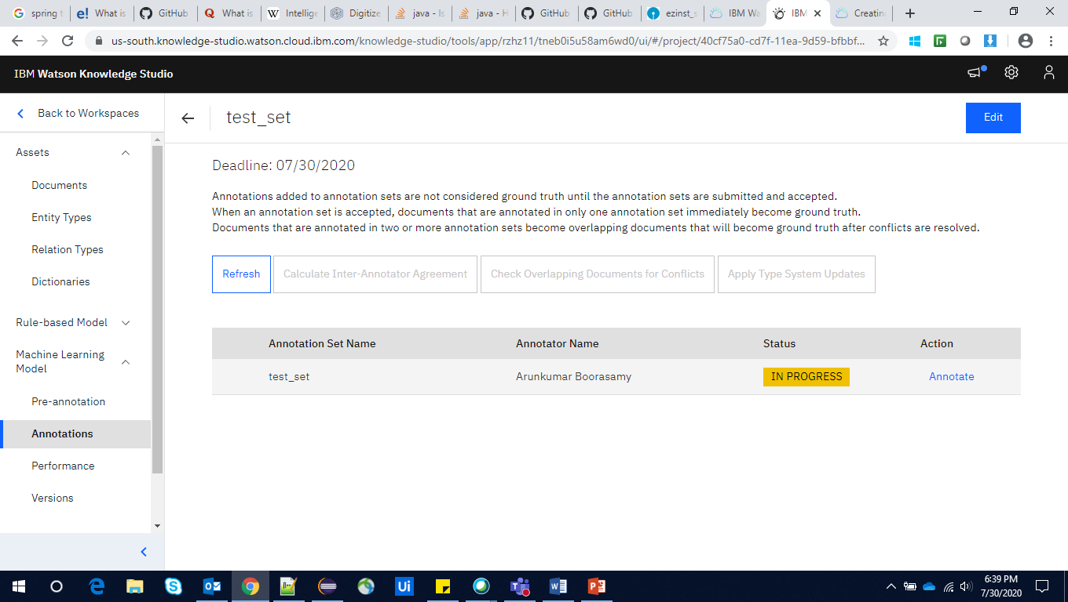

**Step 9**: Select the document

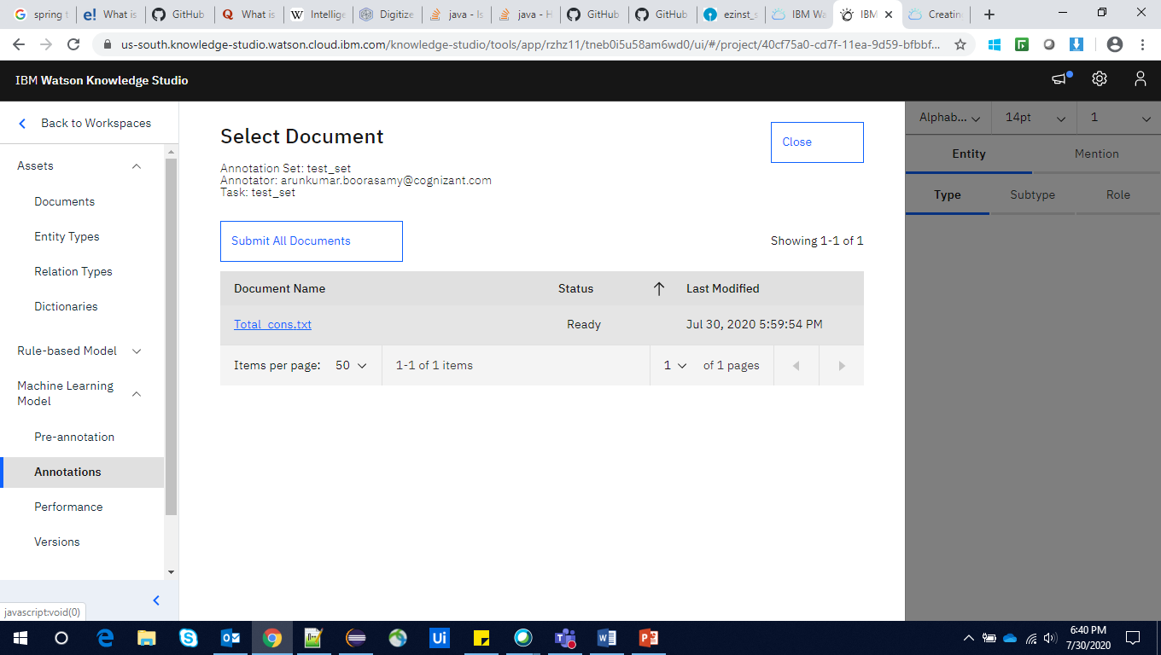

**Step 10**: select the entity type and mark the key word and click space bar.

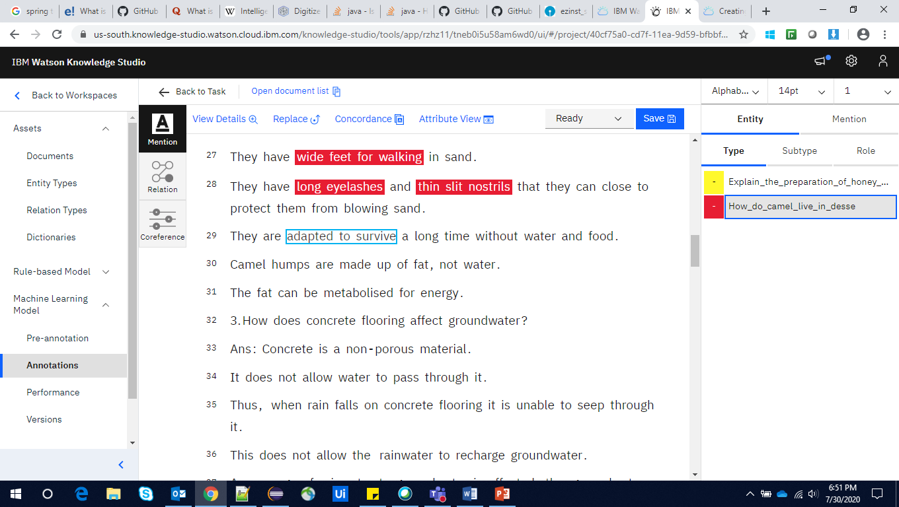

**Step 11**: As the same way mark for all the entities. Once it was done change the status to complete and click on save

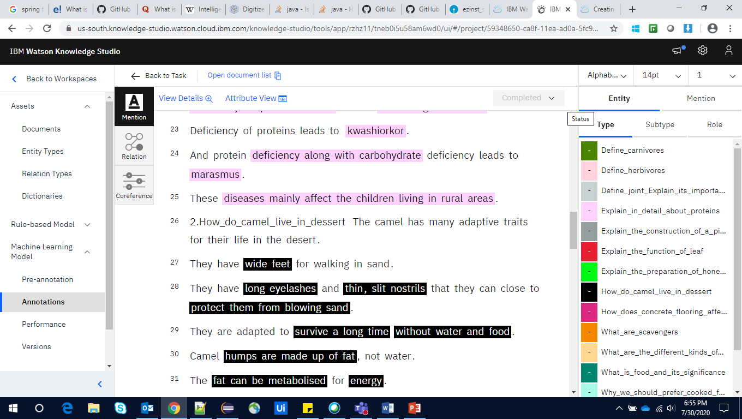

**Step 12**: After the submition it will be back to the task and will show the submition progress once that is completed click on the test set again.

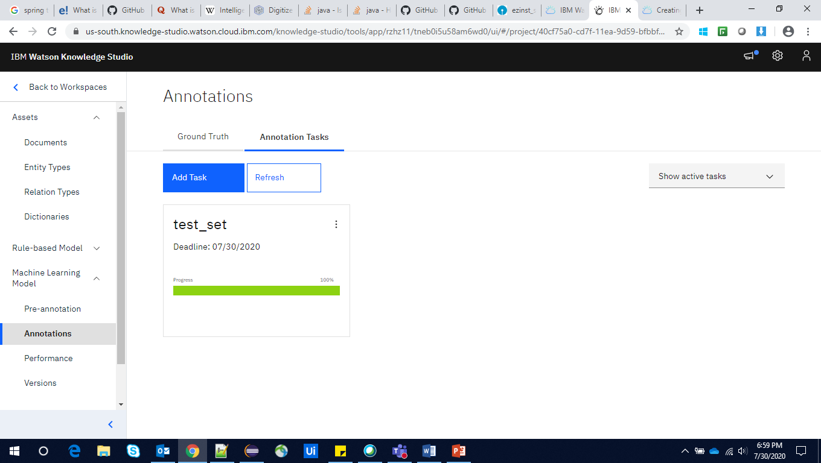

**Step 13**: Mark the set and click on accept. Then the annotation set will be ready to train.

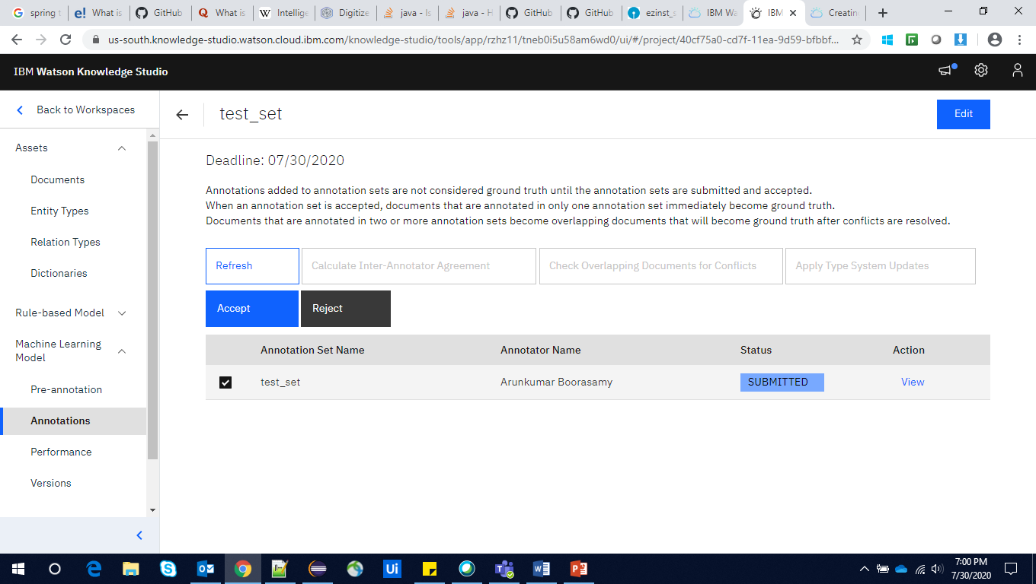

**Training the Model:**

**Step 1**: click **Machine Learning Model > Performance**.

**Step 2**: Click on **Train and evaluate**.

**Step 3**: Select the set which is marked as completed status**.**

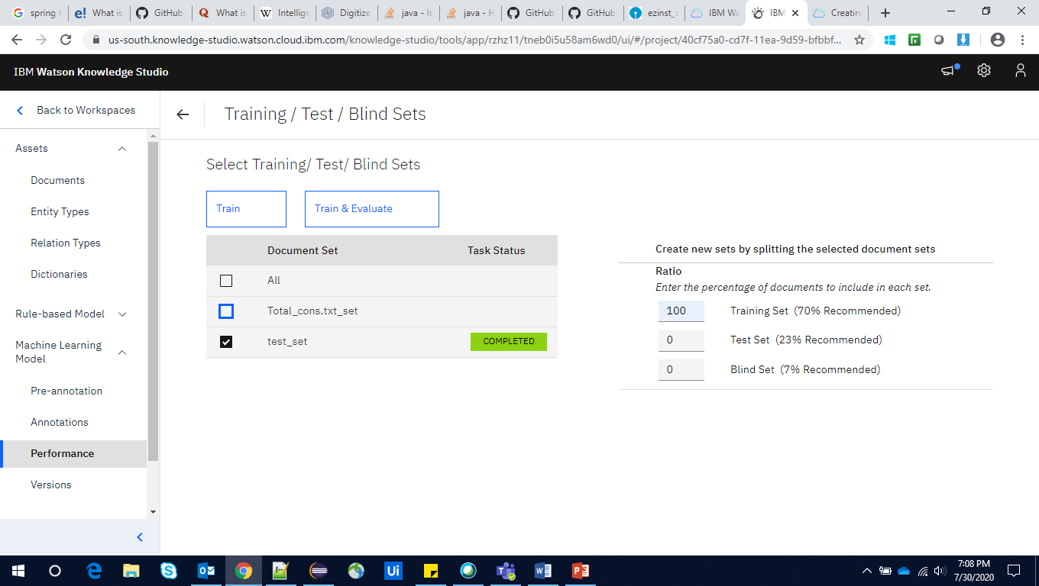

**Step 4**: Click on **train**, it take few minutes to complete the process then you will get the training successful message.

**Step 5**: Click on **versions** and click **create versions** give the description and click ok.

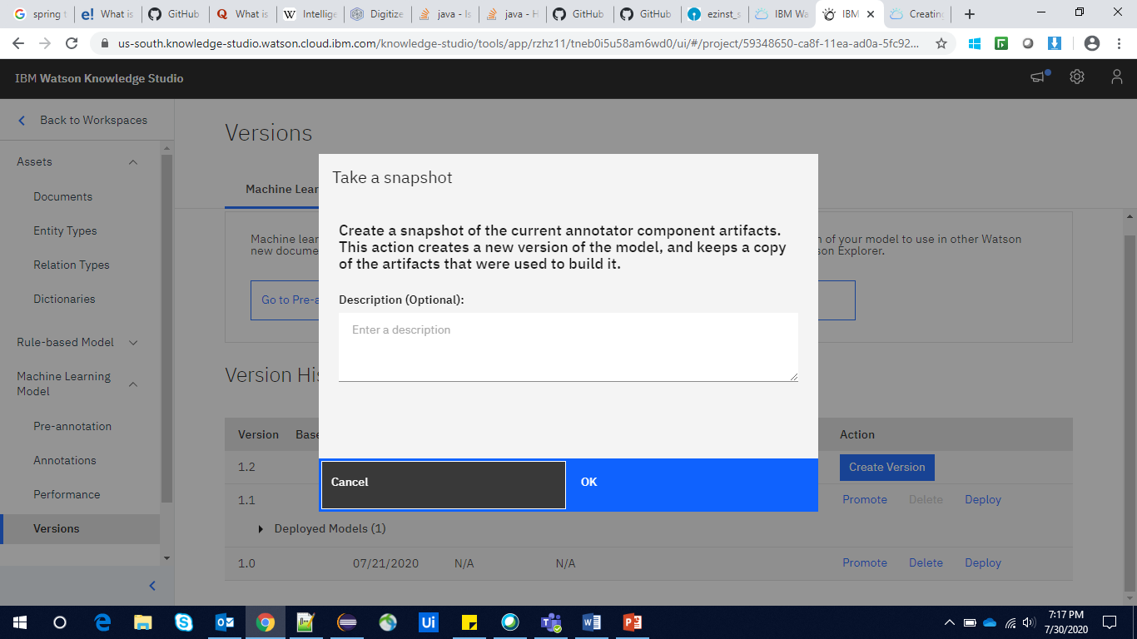

**Step 6:** Once the version is created click on **Deploy.**

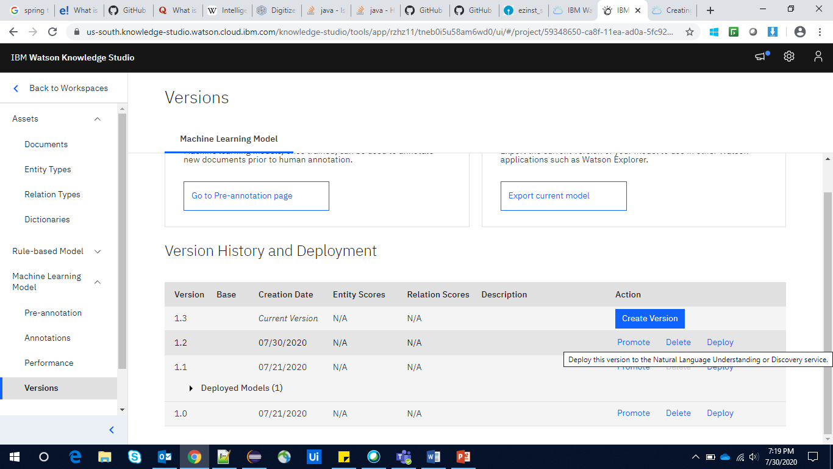

**Step 7**: click on **Natural Language Understanding**.

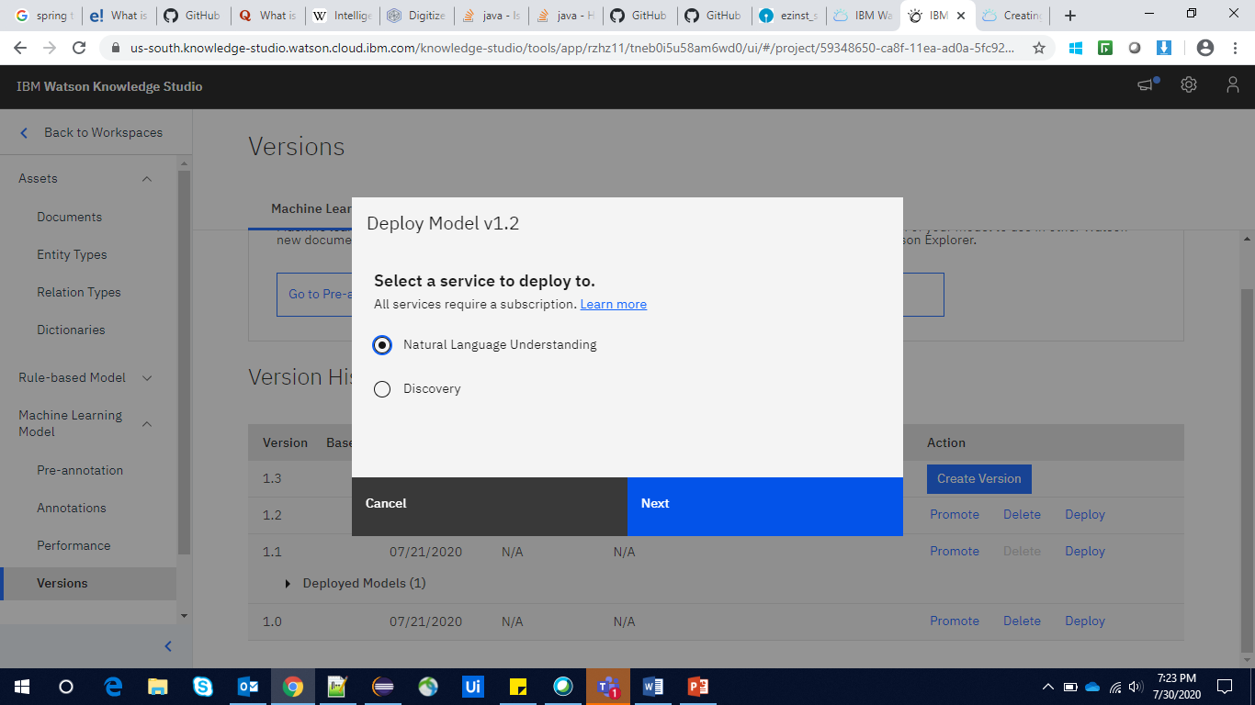

**Step 8**: Select the region, resouce group and service name and click deploy.

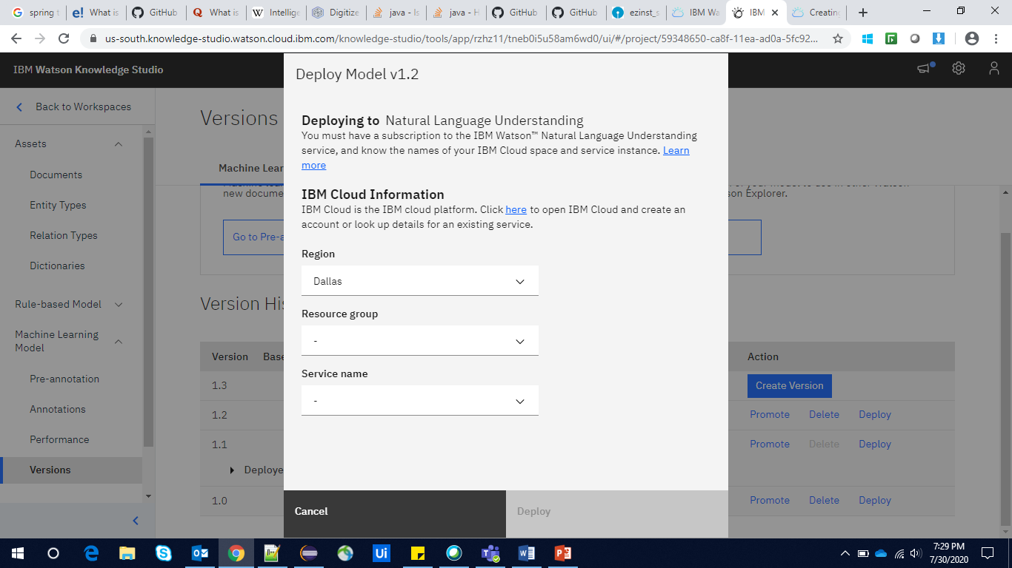

**Step 9**: Once it is deployed we can see the deployed model id.

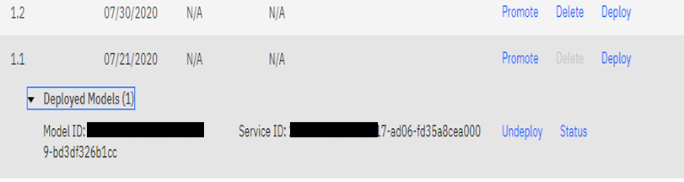

Launch the Natural Language Understanding to get the API Key anh URL to contact the trained model as per the need.

